**ENGLISH TO CHINESE**

**https://24x7offshoring.com/**

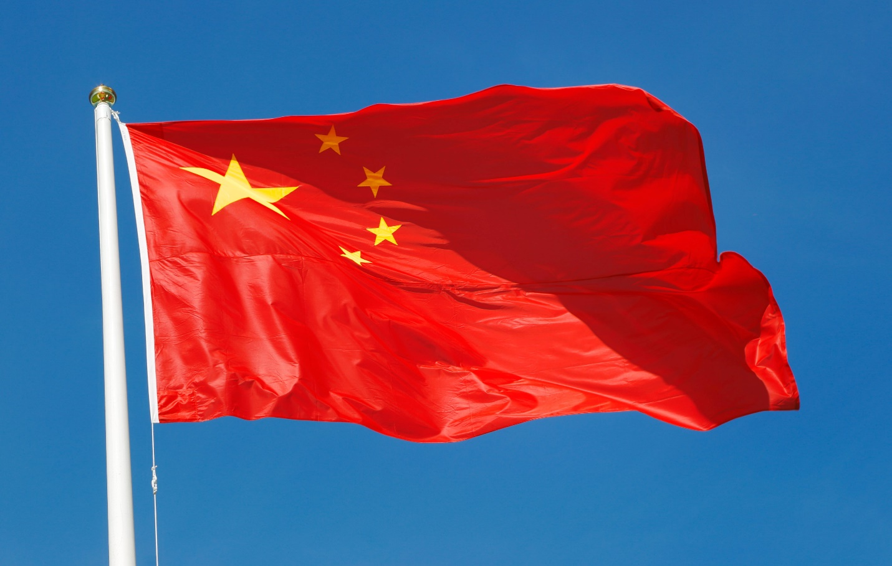[**http://24x7outsourcing.com/**](http://24x7outsourcing.com/)

**Chinese interpretation administrations**

**Chinese Translation Service for Complex Translations**

Regardless of whether you have set up a part of your business in China, or you're a military official positioned in Shanghai, a publicizing organization with a Chinese crowd, or some other business, organization or office, English to Chinese interpretation is turning into an exceptionally requested assistance.

English to Chinese interpretation is anything but a simple assignment to overcome, but then the requirement for Chinese interpreters is developing quickly.

To an ever increasing extent, organizations, offices and people need Chinese archive interpretation for sites, administrations, or to speak with their Chinese colleagues, target crowds, or representatives.

Notwithstanding, Chinese language interpretation isn't straightforward or simple.

That is the reason an excellent, experienced interpretation administration like 24x7offshoring.com, with more than 100 talented Chinese interpreters, are accessible for even the most specialized Chinese interpretation.

Get a free statement in seconds from the top menu, which will give you an itemized gauge. Or then again you can pick to utilize our live visit for a conference or a particular inquiries.

**Numerous Dialects and Variations = Need for Expert Chinese Translation Service**

There are two principle tongues under Chinese language: Cantonese and Mandarin. Cantonese is spoken by those living in Hong Kong and the Guangdong district of China.

Inside Mandarin there exists numerous tongues and changes in jargon, articulation, and sentence structure.

Word and sentence request regularly should be revamped, because of contrasts in language grammar.

Since the Chinese language is based on significance more than formal union, it can frequently appear to be dark or dynamic when made an interpretation of in exactly the same words into an English to Chinese interpretation.

This should be redressed by a specialist Chinese interpreter who sees how to deliver the adequate English same.

In the event that your report, text, site or showcasing materials are inappropriately deciphered, it can cause many humiliating issues for a business.

A non-local speaker would not comprehend or realize best how to change a record or materials to fit specific territorial Chinese crowds.

24x7offshoring.com' Chinese interpreters have deciphered many records for the military, items, materials and archives for migrated business branches, PC innovation manuals, banking data, and considerably more.

Regardless of whether your record is a legitimate, clinical, IT, or monetary content, we have encountered interpreters to give you even the most specialized Chinese interpretation.

**The Best Price for the Best Chinese Translation**

One of the approaches to understand what sort of value you are taking a gander at is to exploit an interpretation administration's free statement alternative.

Generally proficient, experienced Chinese language administrations offer a statement, similar to the one we give on the menu to one side.

By looking at these statements, you can make an insightful allowance about which administration will give the best Chinese archive interpretation at the best cost.

Our top master Chinese interpreters are holding on consistently.

The menu on the left will give a free statement, and permit you to contrast costs and different administrations. You'll see that 24x7offshoring.com will be the most exceptional, experienced

Chinese to English interpretation administration, with unquestionably the least rates.

Utilizing our coordinated arrangement of offering interpreters who strive for every interpretation work, you are ensured experienced and skillful interpretation benefits at the most ideal cost.

**ENGLISH TO CHINESE**

**https://24x7offshoring.com/**

**http://24x7outsourcing.com/**